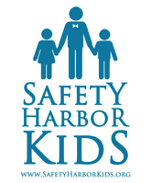

**SAFETY HARBOR KIDS 9th POLO CLASSIC CARITY FUNDRAISER *20% EARLY BIRD SPECIAL EB AVAILABLE FOR A LIMITED TIME***

Safety Harbor Kids 9th Annual Polo Classic Luncheon to benefit orphans, foster and homeless children. **Saturday, September 10th, from 1:00 - 5:00 pm at Will Rogers Polo Club in Pacific Palisades, CA.**

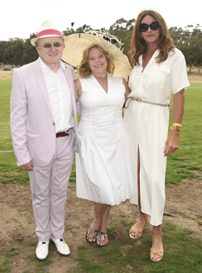

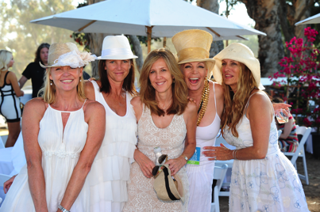This will be a private, secure affair on the polo grounds

at Will Rogers, one of the most beautiful locations in California’s “Golden Triangle”. With ocean views and special musical entertainment by GRAMMY winner Albert Lee, you will dine on five star cuisine in our VIP area or in your private cabana while enjoying the game of kings. With half time entertainment by Dream World Cirque, your refreshments will include high tea by Charles and Company Tea, signature cocktails by Dama Tequila, wine tasting and water by Hint. Red carpet, celebrity guests, meet & greet and international press, a live and silent auction, are also included in this day of days.

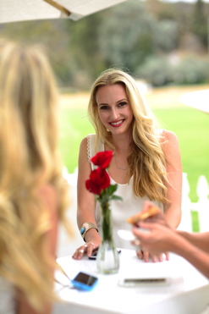Presentation tables available. Invite your friends, family and clients to enjoy a day of opportunity and adventure. Please visit www.safetyharborkids.org or call (800) 277-0497 today to reserve your company table. Space, tables and cabanas are limited in number so **reserve your tables now for the party of the year!**

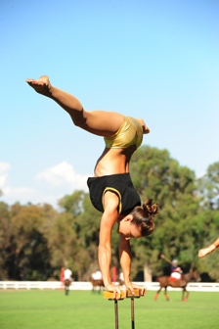

**Polo Fundraiser Private VIP table for 8** in the VIP area, field side with prime view of the match. Feel the exhilaration as the horses go thundering by while you enjoy your appetizers and cocktails, wine tasting, high tea, dinner, and entertainment. Red carpet opportunity, meet & greet, gift bags, and fresh air and ocean view included

**•VIP Tables For 8 $2600**

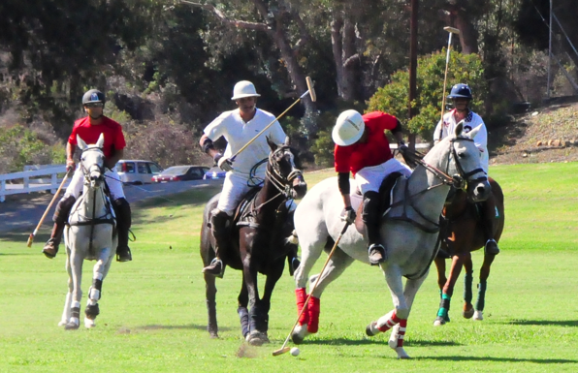**20% EB discount $2080**

**•All VIP Packages include •VIP Lounge $345**

VIP Red Carpet Opportunity **EB 20% discount $275**

Gourmet Meal & Appetizers

Open Bar, High Tea & Gift Bags **•VIP Cabanas For 8 $3500**

Open Bar & Entertainment Full VIP Package

& Live Entertainment Very Limited number

**•Lords & Ladies $10,000 •Knights $5000**

**EB 20% discount $8,000 EB 20% discount $4000**

Banner & logo or name exposure Banner & logo or name

exposure Full VIP Service & Package Full VIP Service & Package **•General Admission $95**

VIP Cabana for 12 EB 20% Discount $75

Full VIP Service & Package Available for a limited time

**ABOUT SAFETY HARBOR KIDS** Safety Harbor Kids is a Malibu, 501c3, founded for the purpose of enriching the lives of parentless and homeless children through education in the areas of College, Career, Music, and the Arts. We tutor them in academics, music and art . We teach them Etiquette and Manners and we help them get jobs, we treat them to a holiday gifts, and we give more than 1000 gifts each year to orphans, foster and homeless children. We means YOU and Safety Harbor Kids

Please join Southern California Edison, Neiman Marcus and Pepperdine University and Santa Monica Kiwanis in supporting Safety Harbor Kids Personal Growth Programs.

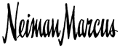 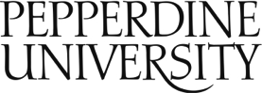 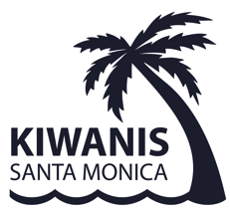

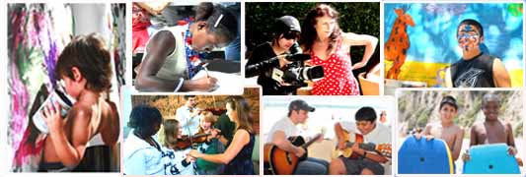! Thanks for donating to help a deserving child have a chance at a decent life. Please go to [www.safetyharborkids.org](http://www.safetyharborkids.org) today to attend or sponsor a child.